# ****Function Notation****

The notation $y=f(x)$   defines a function named $f$ . This is read as “ $f$ is a function of $x$ ” or $"f$ of $x$.”

The letter $x$ represents the input value, or independent variable. The letter $y$  or $f(x)$  represents the output value, or dependent variable.

For the function $y= f(x)$

$f$ is the name of the function

$x$ is the domain value (or independent variable)

$f(x)$ is the range value $y$ (or dependent variable) corresponding to the value $x$

Example: Evaluate the function for the given values.

Given $f\left(x\right)=3x^{2}-2x+4$, find



$f(-2)$

$f(x+1)$

$f(3)$

$f(-x)$

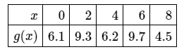Example: Use the table of values for $g$ to evaluate $g(2)$ and $g(8)$. Then find all values of $x$ so that $g(x)=6.2$.

Example: The number of unread emails in Anthony’s account is 110. This number grows by 25 unread emails a day. The function $N\left(t\right)=110+25t$ represents the relation between the number of emails, $N$, and the time, $t$, measured in days.

* 1. Find and explain what it means.
  2. If Anthony’s account has 285 unread emails, how many days did he not read his emails?

Example: Below is a graph from the CDC showing the number of measles outbreaks in the US since 2010. Find and interpret .

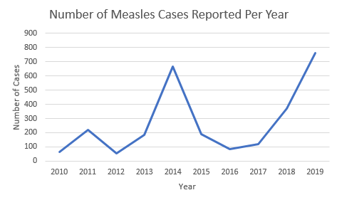

[Source](https://www.cdc.gov/measles/cases-outbreaks.html)

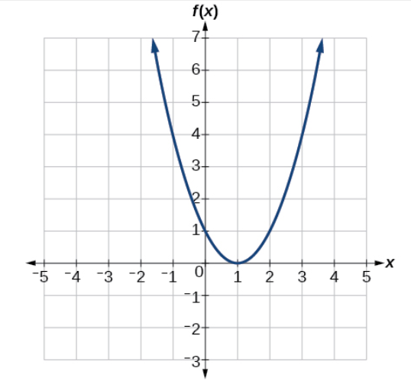 Example: Using the graph,

1. Evaluate $f(2)$.
2. Solve $f\left(x\right)=4$.

# Even and Odd Functions

Even and odd functions are special types of functions.

An even function is a function that is symmetrical about the $y$-axis (reflects across the y-axis). An odd function is symmetrical about the origin (if you rotate if about the origin, it will look like the original graph after making a 180 degree rotation). Note: not all functions are even or odd. There are some that can be neither.

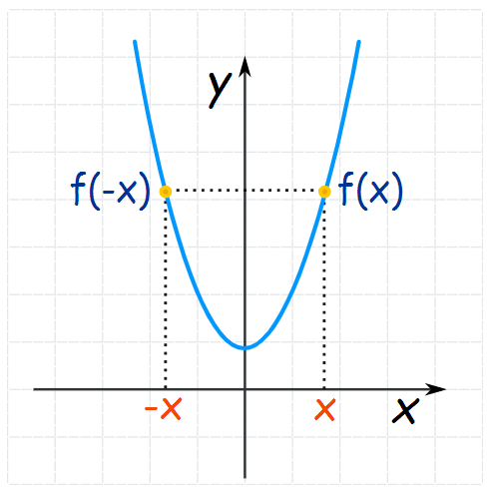 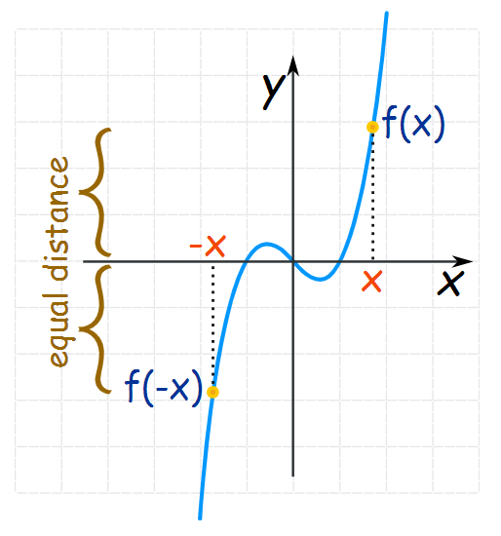

Even Function Odd Function

## How to Determine Algebraically if a Function is Even, Odd, or Neither

To determine whether a function is even or odd (or neither) algebraically, we take the function and plug in $–x$ and then simplify. The result helps you determine which type of function it is.

If $f\left(-x\right)=f(x)$, then

If $f\left(-x\right)=-f(x)$, then

In all other cases, the function is neither even nor odd.

Examples: For each of the following, determine algebraically whether the function is even, odd, or neither.

$f\left(x\right)=2x^{3}-4x$

$f\left(x\right)=2x^{3}-3x^{2}-4x+4$

$f\left(x\right)=-3x^{2}+4$